**New Employee Orientation Webinar**

**Login and User Instructions**

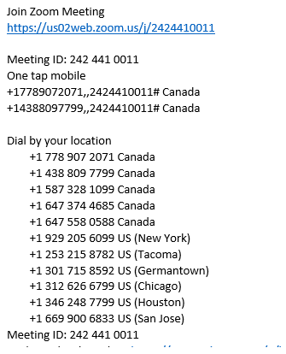The following information will assist you in logging into the New Employee Orientation. Please following the steps below:

**Computer URL Login**

Click on the link sent in your email. If you did not get a link in your email please type the URL in the red box in your browser address bar.

**Phone Number Login**

ZOOM works best on a computer but if you do not have access to a computer please dial any one of the numbers in the green box. You will be asked to dial the meeting ID and press #. You do not have a participant ID. Please tell the administrator your name so we can complete our attendance and place your name on your user ID.

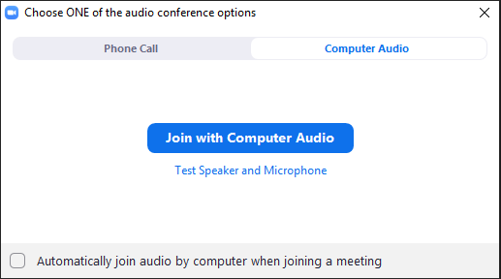**Audio Connection**

For participants using a computer a message will appear asking to choose audio. Please click on the ‘Join with Computer Audio’ option.You will be connected to the ZOOM

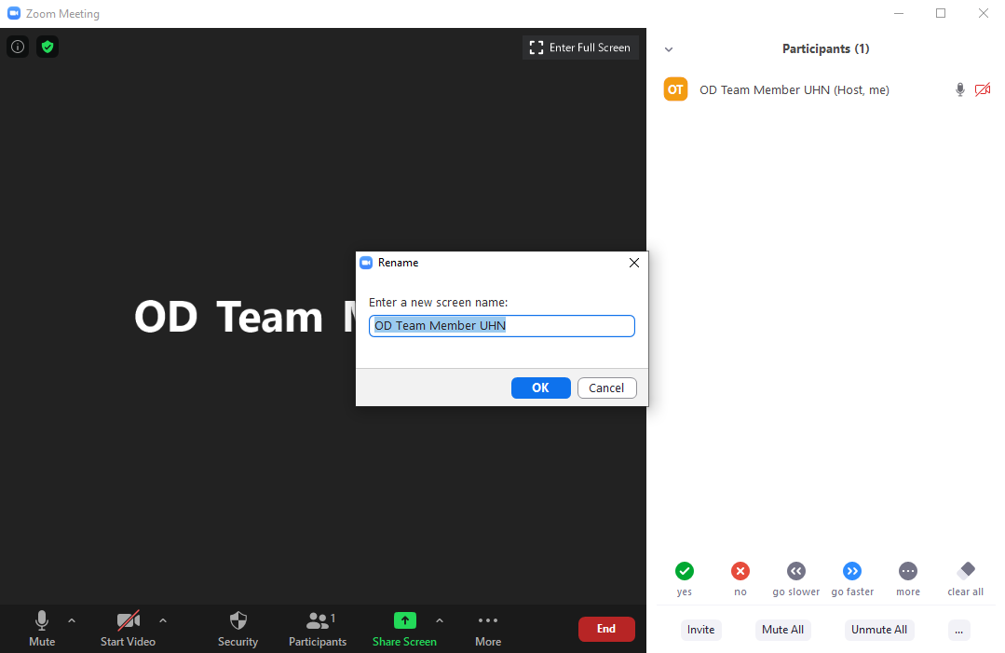**Change Your Display Name**

1. When your display appears, please click on the ‘Participants’ Tab, this will open the participants list (red box).
2. Locate your current name and click on it (blue box). Select the ‘More’ tab.
3. Click on ‘Rename’
4. ****Please type your first and last name and click OK so we can complete our attendence (green box).

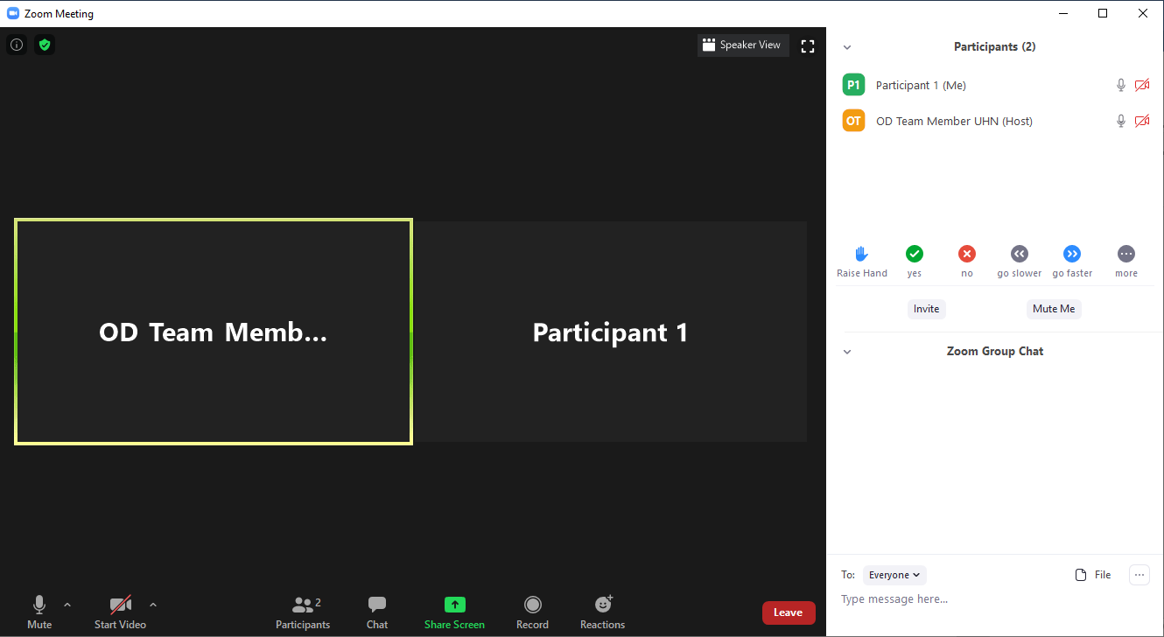**Navigating the ZOOM Window**

6.

5.

4.

3.

1.

2.

**Index of ZOOM Window Tools**

1. **Video Screen**

This is where you can view the other participants video or screenshare. You can change the amount of screens displayed by toggling the video options located in the top right portion of the screen.

1. **Menu Bar**

Click on the different tabs to mute/unmute your microphone, turn on/off your camera, open/close the participants list, open/close the chat window, start sharing the screen on your computer, record the webinar or send a reaction to the group.

1. **Participants List**

You can see a list of everyone in the New Employee Orientation in this list. Click on your name to change your name. Click on the microphone and camera icon to mute/unmute your microphone and to turn on/off your camera.



1. **Interaction Icons**

Click on the appropriate icon to send a non-verbal communication or answer to the class/instructor.

1. **Group Chat**

Type messages you want to send to an audience of your choice. Click on the dropdown menu to select a the person you are sending a private message to or leave it on everyone to send a message to the class. **This will be used for introductions for people without a microphone.**

1. **Leave Icon**

Click on this icon or the close icon at the top of the window to leave the New Employee Orientation.

**Technical Assistance**

We suggest if this is your first time using ZOOM that you login 15 minutes early. If you are experiencing any technical issues accessing the New Employee Orientation please email [iain.sintzel@uhn.ca](mailto:iain.sintzel@uhn.ca) or [meghan.macdonald@uhn.ca](mailto:meghan.macdonald@uhn.ca). We will assist you with logging in and any other questions you may have.

